Logic Gates – give the answer in this document itself. You can snip the diagram and write on it before pasting into this document.
1.
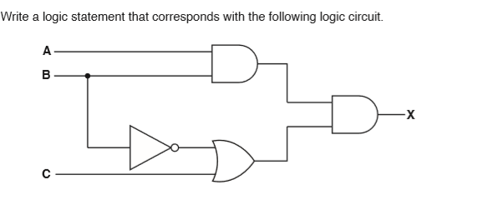
2.
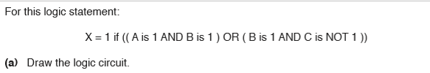
3. 